1. Return the first name, last name, and department name for all employees including those employees not assigned to a department.

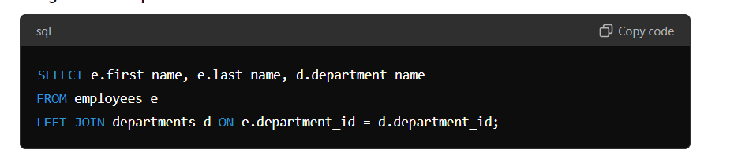

2. Return the first name, last name, and department name for all employees including those departments that do not have an employee assigned to them.

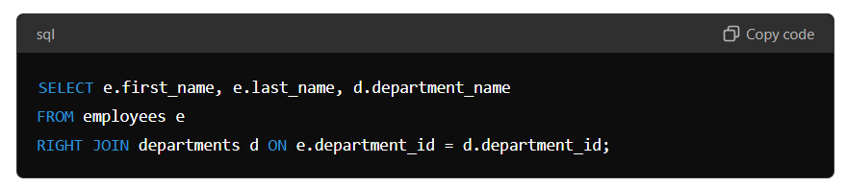

3. Return the first name, last name, and department name for all employees including those departments that do not have an employee assigned to them and those employees not assigned to a department

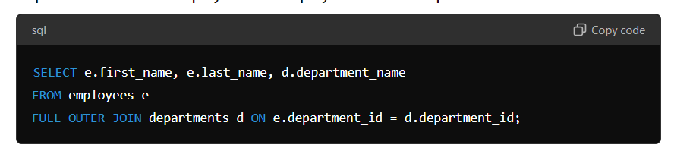

. 4. Create a query of the DJs on Demand database to return the first name, last name, event date, and description of the event the client held. Include all the clients even if they have not had an event scheduled

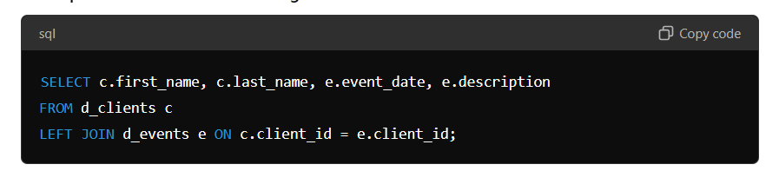.

5. Using the Global Fast Foods database, show the shift description and shift assignment date even if there is no date assigned for each shift description.

